1. Xem dia chi thanh ghi SFR o file **sfr884200.h**

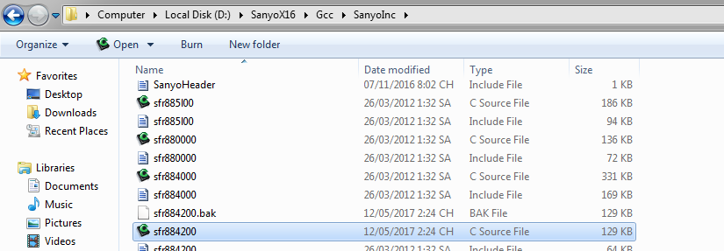

1. Thanh ghi DDR. 1: Output, 2: Input
2. Clock source VCO duoc lấy ra từ pin LPFO
3. Illumination có tác dụng khi bật đèn lên buổi tối thì màn hình DVD sẽ tự động giảm độ sáng để chống chói mắt

 An illumination wire simply lets the head unit detect when your headlights are on. When voltage is detected on the wire, the unit will dim the display so that it doesn't hurt your night vision. It is NOT for turning on the radio display lights, and it does NOT allow you to adjust the head unit display using the vehicle dimmer switch. It just dims the display when your lights turn on.   
  
The factory radio harness usually contains one or more illumination wires. You can test for it using a multimeter. A true illumination wire will show 12 volts with the parking lights on, and 0 volts with the lights off; it won't vary with the dimmer switch. You may find a "dimmer" wire, which will show voltage with the parking lights on, but the voltage will vary as you adjust the switch. You can connect the new radio's illumination wire to either one and it will work, but using the true illumination wire is better.

1. Since your buzzer already have the 'buzz' inside you could consider driving it by toggling a port pin only turning on/off a transistor to turn buzzer on/off. You do not need to worry about PWM at all then
2. Since your buzzer already have the 'buzz' inside you could consider driving it by toggling a port pin only turning on/off a transistor to turn buzzer on/off. You do not need to worry about PWM at all then (trang 108 theo sách)